EE 205 Circuit Theory
Lab 9
Steady State Sinusoidal Response (Phasor Analysis)

Procedure:

Consider the RC circuit shown in Fig.1 with C=1uF, R=10. Use a cos source signal with 10V peak and 0V offset at 100kHz frequency. We aim to find the steady state V_{C}(t).

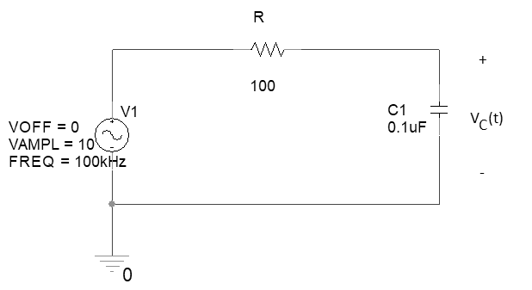
Fig.1. Steady State RC Circuit

The phasor impedance of the capacitor is
$$Z_{C}=\frac{1}{jωC}=\frac{-j}{2π({10}^{5})({10}^{-7})}=\frac{-j100}{2π}≅-j16 Ω$$
Thus, the capacitor voltage phasor is
$${\overline{V}}_{C}=10×\frac{-j16}{100-j16}≅0.25-1.6j≅1.58∠-1.4158≅1.58∠-{81}^{0}$$
The time expression of the capacitor voltage is
$$V_{C}\left(t\right)=Re\left\{{\overline{V}}_{C}e^{jωt}\right\}=1.58cos⁡(ωt-{81}^{0})$$
Table 1. Calculated and Measured Values
Calculated Values for V_{C} |  | Measured Values for V_{C}
$Amplitude$  (V) | $Phase$  (degrees) | $Amplitude$  (V) | $Phase$  (degrees)

