EE 205 Circuit Theory
Lab 8
RLC Circuit Underdamped Response

Procedure:

Consider the RLC circuit shown in Fig.1 with C=8.2nF, R=10k and L=4.6uH. Use a square wave source signal with 10V peak-to-peak and 5V offset at 1kHz frequency.

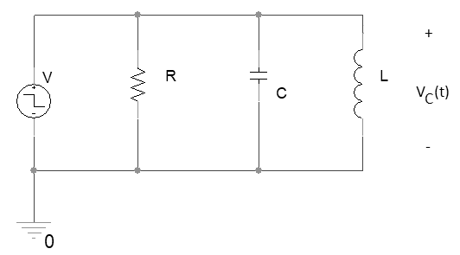
Fig.1. RLC Circuit

Connect an oscilloscope probe to V_{C}(t). You may use “autoset” to view the output on the scope screen. Since this circuit is underdamped, you should observe a damped oscillation. Measure the oscillation frequency. Fill Table 1 with the measured and calculated values.
Note that
$$α=\frac{1}{2RC}$$
$$ω_{0}=\frac{1}{\sqrt{LC}}$$
and $ω_{d}=\sqrt{ω_{0}^{2}-α^{2}}$

Table 1. Calculated and Measured Values
Calculated Values |  |  |  | Measured Values
$α$  (Damping factor) | $ω_{0}$  (resonant frequency) | $$ω_{d}$$  (Damped radian frequency) | Damping time ($\sim 5α$) | $$ω_{d}$$ | Damping time

