EE 205 Circuit Theory
Lab 6
Mutual Inductance and Dot Conversion

If we place two inductors close together they start to affect one another. This occurs in the form of inducing voltage of one inductor current on the other inductor and visa versa. Strength of the induced voltage is increased when we use a ferrite material such as iron between the two inductors. Such device is called “toroidal transformer”. The circuit symbol and the physical appearance are given in Fig.1.

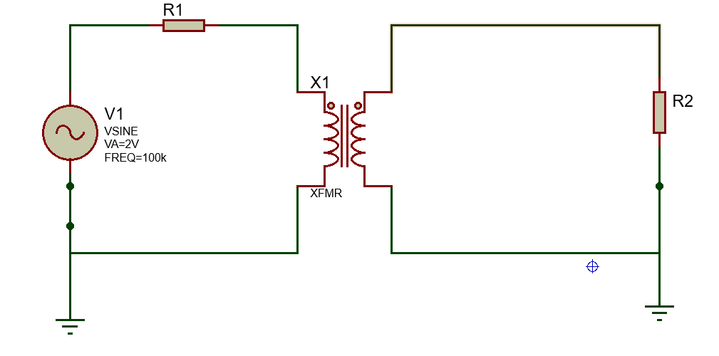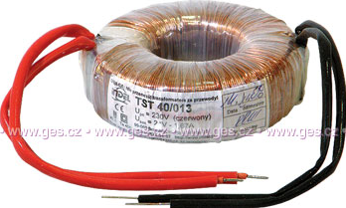
Fig.1. a. Transformer circuit schematic b. Physical appearance

The strength of the interaction between the inductors are measured by a constant M=Mutual Inductance. Generally, for an ideal toroidal transformer, we have the following relation:

$$\frac{V_{1}}{V_{2}}=\frac{N_{1}}{N_{2}}$$

where N1 and N2 are the number of turns in the first and second coils respectively. One side of this equation becomes negative if we have the opposite dot placement.

The polarity of the induced voltage on the 2nd circuit due to the current in the 1st circuit is determined by the “dot convention”.

Lab procedure

- Implement the circuit given in Fig.1. with V_{s}=4V peak-to-peak amplitude, R₁=shorted (wire), R₂=open circuit (high resistance). Here, we use the function generator for Vs (V₁) and connect oscilloscope probes across R2 to measure V₂ (V_{L}). Measure the amplitudes of the voltages V₁ and V₂ and fill Table 1 for different number of turns.

Table 1. Calculated and Measured Values
N1=2 turns, N2=1 turn |  | N1=1 turn, N2=2 turns
Calculated V1, V2 | Measured V1, V2 | Calculated V1, V2 | Measured V1, V2
N1=3 turns, N2=1 turns |  | N1=1 turns, N2=3 turns
Calculated V1, V2 | Measured V1, V2 | Calculated V1, V2 | Measured V1, V2
N1=4 turns, N2=1 turns |  | N1=1 turns, N2=4 turns
Calculated V1, V2 | Measured V1, V2 | Calculated V1, V2 | Measured V1, V2

Conclusion and Discussion:
Does dot convention give the correct voltage polarity at the 2nd circuit ?

