EE 205 Circuit Theory
Lab 4
Maximum Power Transfer Theory

The objective of this lab is to experiment the maximum power transfer theorem. Consider a load resistor connected to a circuit that can be modelled by a Thevenin voltage source and a resistance as shown in Fig.1.
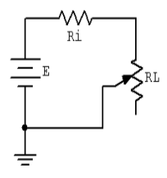
Fig.1. Test circuit for max. power transfer

Under this condition, we determine the value of the load resistor at which the maximum power is consumed. This condition is satisfied at
$R_{L}=R_{i}$.

Any load resistance value above or below this will produce a smaller load power. System efficiency (η) is 50% at the maximum power case. This is because of the fact that both resistors cosumes the same amount of power at this condition.

Lab procedure

- Implement the circuit given in Fig.1. with E=10V, Ri=3.3k. Here, Ri forms a simple voltage divider with RL. The power in the load is
$P_{L}=\frac{V_{L}^{2}}{R_{L}}$,
and the total circuit power is given by
$P_{T}=\frac{E^{2}}{R_{i}+R_{L}}$ .
Efficiency can be computed as
$η(\%)=\frac{P_{L}}{{P_{T}|}_{P_{L} is max.}}×100$.

- Using RL values in Table 1, compute the analytic values for load voltage, load power, total power and efficiency, and record them in Table 1. Repeat the procedure by computing the power and efficiency according to measured values for VL. For the middle entry labeled Actual, insert the 3.3 k used for Ri.

Table 1. Calculated and Measured Values
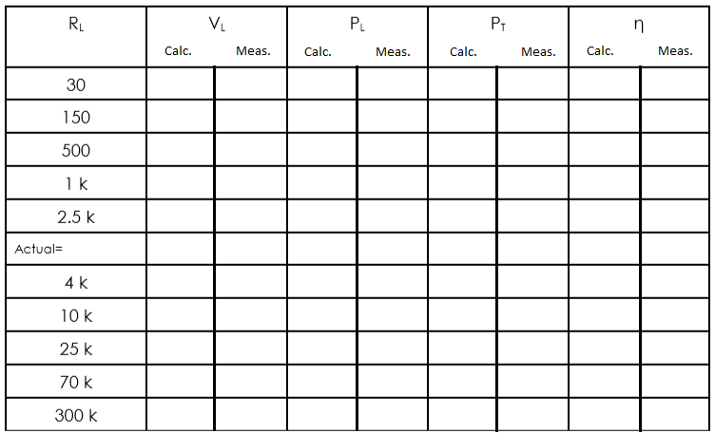

- Draw two plots of the efficiency versus the load resistance value using the measured data from the table. One for theoretical, one for experimental. For best results make sure that the horizontal axis (RL) uses a log scaling instead of linear.

Graphs:

