EE 205 Circuit Theory
Lab 2
Thevenin Theorem

The aim of this lab is to apply and verify Thevenin’s theorem.

Thevenin’s theorem states that in a circuit containing voltage and/or current sources and resistors, all the circuit elements can be replaced by a single voltage source in series with a resistor with respect to any two terminals.
This voltage source is called the “Thevenin v

oltage” and the resistor is called the “Thevenin resistance”.
Thevenin voltage is calculated by finding the open circuit voltage at the terminals.
To find the Thevenin resistance, we follow the following steps:
- Short circuit the terminals, and find the short circuit current (I_{SC}).
- Thevenin resistance can be calculated from R_{TH}=V_{TH}/I_{SC}.

Lab procedure
- Constructed the following circuit. Use the following values:
E=10V, R1=3.3k, R2=6.8k, R3=4.7k, and R4=R_{LOAD}=8.2k.

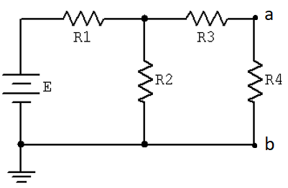
Fig.1. Thevenin circuit with respect to terminals a and b.

- Calculate the voltage and current for the load resistor R4. Write them in Table 1.
- Measure the voltage and current for the load resistor R4. Write them in Table 1.

Table 1.
Calculated Voltage | Measured Voltage | Calculated Current | Measured Current

- Calculate the Thevenin voltage and resistor with respect to terminals a and b.
V_{TH}= _________________
R_{TH}= _________________

- Construct the following Thevenin equivalent circuit: RL=R4.
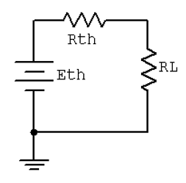
Fig.2. Thevenin equivalent circuit.

- Calculate the voltage and current for the load resistor R4. Write them in Table 2.
- Measure the voltage and current for the load resistor R4. Write them in Table 2.

Table 2.
Calculated Voltage | Measured Voltage | Calculated Current | Measured Current

Conclusion:
Make comments on Table 1 and Table 2.

