EE 205 Circuit Theory
Lab 2
Kirchoff’s Current and Voltage Laws

The aim of this lab is to analyze basic series DC circuits with resistors. A key element is Kirchhoff’s Voltage Law which states that the sum of voltage rises around a loop must equal the sum of the voltage drops.

Lab procedure
KVL:
A closed loop circuit is implemented by connecting three resistors in series as shown in the figure below . The current is the same at all points in the loop and may be found by dividing the total voltage source by the total resistance. The voltage drops across any resistor may then be found by multiplying that current by the resistor value. An alternate method to find the voltage is the voltage divider rule.

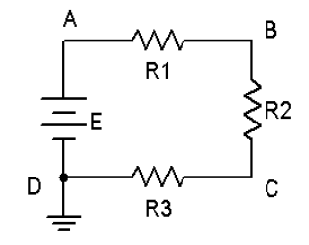
Figure 1. KVL example

- Use R1 = 1 k, R2 = 2.2 k, R3 = 3.3 k, and E = 10 volts, determine the theoretical current and voltages across each resistor. Record them in Table 1 below. Construct the circuit. Set the DMM (Digital Multi Meter) to read DC current and insert it in the circuit at point A. Remember, ammeters must be connected in series with the circuit. The red lead should be placed closer to the positive source terminal. Record this current.

Current in Theory:___________ Current in Measurement:___________

- Set the DMM to measure DC voltage. Remember, unlike current, voltage is measured across components. Place the DMM probes across R1 and measure its voltage. Again, red lead should be placed closer to the positive source terminal. Record this value in Table 1. Repeat this process for the voltages across R2 and R3. Determine the percent deviation between theoretical and measured for each of the three resistor voltages and record these in the final column of Table 1. What causes these deviations ?

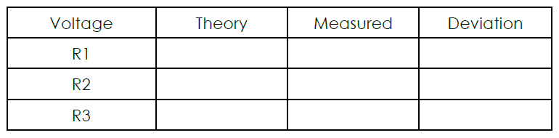
Table 1.

KCL:
Parallel DC Circuit.

A circuit with two resistors connected in parallel is implemented as shown in the figure below. The current is divided at node B into two parts. The current in each branch through resistors may then be found by dividing the voltage E by the resistor value. An alternate method to find the current is the current divider rule.
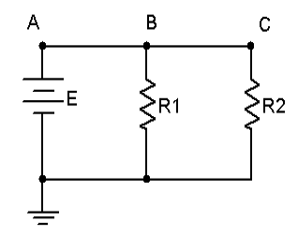
Figure 2. KCL Example Circuit

- Using the circuit of Figure 6.1 with R1 = 1 k, R2 = 2.2 k and E = 8 volts, determine the theoretical voltages at points A, B, and C with respect to ground. Record these values in Table 2. Construct the circuit. Set the DMM to read DC voltage and apply it to the circuit from point A to ground. The red lead should be placed at point A and the black lead should be connected to ground. Record this voltage in Table 2. Repeat the measurements at points B and C.
- Set the DMM to measure DC current. Remember, current is measured at a single point and requires the meter to be inserted in-line. To measure the total supplied current place the DMM between points A and B. The red lead should be placed closer to the positive source terminal. Record this value in Table 2. Repeat this process for the currents through R1 and R2. Determine the percent deviation between theoretical and measured for each of the currents and record these in the final column of Table 2.
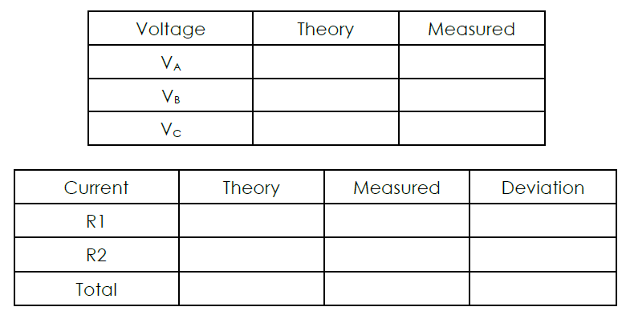
Table 2.

Results and Conclusion:
Write the summary of what you have learned in this lab.

