EE 205 Circuit Theory
Lab 1
Laboratory Devices

- Fundamental Concepts:

Charge:
Charge: Electrons, protons
Unit of charge is Columbs.
6.2415x1018 proton= 1C.
e= - charge, p=+ charge

Electric Potential= Voltage
Battery= Electrical devide that is made of seperating charges.
Voltage=Electric potential energy (J)/Charge(C)
+ and – cahrges are located at the baterry terminals.
Unit of voltage is volts (V)
Potential difference is dependent upon the charge difference between two points. Hence, it is also called the potential difference.
1V is equal to 1J of energy done by 1C charge.

Electric current: The amount of charge moving in unit time.
The unit of electric current is Ampere (A).
1A is the flow of 1C of charge in 1sec.
Types of electric current:AC (Alternating current), DC(Direct current)
Conduction current occurs through the motion of electrons in a conductor.

Conductors and Insulators:
Conductors: contains lots of free charges.
Insulators: do not contain free charges, high energy is reqıired to seperate electrons for motion.
Semi-conductors.

Resistance:
Resistance is how much a matter opposes against the electric current.
Unit is ohms.
Resistance=R=l/(sigma xS)
Impedance: Resistance in AC circuits.

Electric circuit: is the connection of batteries and resistors through conducting wires.
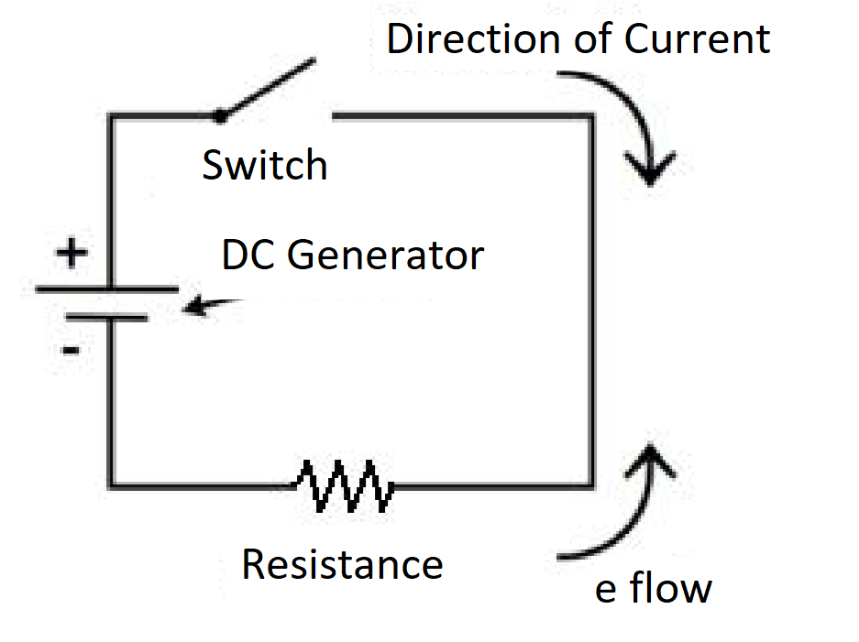
Fig1. Electric Circuit
Ohms law: In a closed electric circuit, V=IR
The power consumed in a resistor: P=IV (W)
The consumed energy(J)=Pxt

- DC Power Supply:
It is a device used for generating DC voltages. It has three terminals as + terminal, - terminal and ground. Current limiter puts a limit on the current
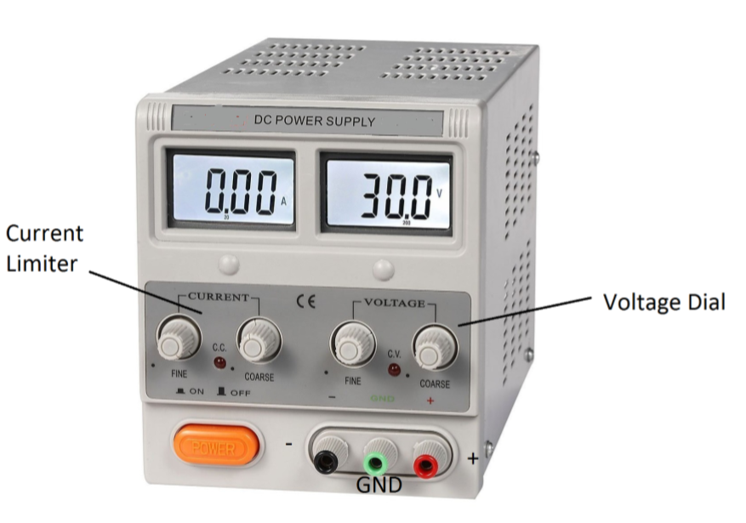
Figure 2: DC Power Signal

supplied by the generator. If the LED for the current lights, this indicates a current limit. That is more current is demanded than the device can supply. Usually, a short circuit can cause such a case.
The maximum voltage that can be generated is usually 30V.

- Breadboard:
Breadboard is used to connect wires with electrical components and devices in order to implement electric circuits. A typical breadboard is shown below.
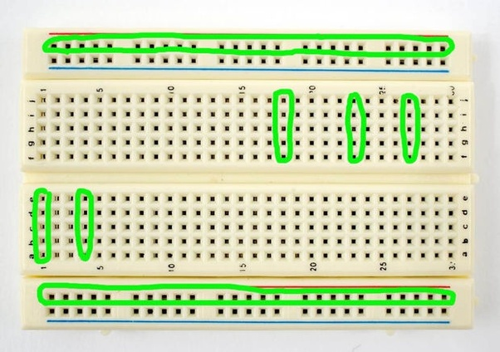
Fig.3. Breadboard

There are many small holes where you can insert the tip of a wire to make connections. Internally, vertical 5 holes are electrically connected (the colored holes in the Figure) and horizontal holes at the edges or center are inter-connected.

- Resistors:
The resistor color code typically uses 4 color bands. The first two bands indicate the precision values while the third band indicates the power of ten applied (i.e. the number of zeroes to add).
The fourth band indicates the tolerance.
It is important to note that the physical size of the resistor indicates its power dissipation rating, not its ohmic value.
Each color in the code represents a numeral. It starts with black and finishes with white, going through the rainbow in between:
0 Black 1 Brown 2 Red 3 Orange 4 Yellow 5 Green 6 Blue 7 Violet 8 Gray 9 White
For the fourth, or tolerance, band:
5% Gold 10% Silver 20% None
For example, a resistor with the color code brown-red-orange-silver would correspond to 1 2 followed by 3 zeroes, or 12,000 Ohms (more conveniently, 12 kOhms). It would have a tolerance of 10% of 12 k Ohms or 1200 Ohms. This means that the actual value of any particular resistor with this code could be anywhere between 12,000-1200=10,800, to 12,000+1200=13,200. That is, 10.8 k to 13.2 k Ohms.

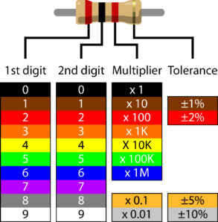
Fig.4. Resistor Color Codes

- Engineering Notations:
Engineering notation goes one step further by using a set of prefixes to replace the multiples of three for the exponent. The prefixes are:

E12 = Tera (T) E9 = Giga (G) E6 = Mega (M) E3 = kilo (k)
E-3 = milli (m) E-6 = micro (μ) E-9 = nano (n) E-12 = pico (p)

Thus, 23,000 volts could be written as 23E3 volts or simply 23 kilovolts.

- A Simple Electric Circuit Analysis and Digital Multimeter Measurements

Construct the following circuit, and make a voltage and current measurement
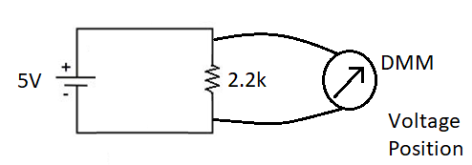
Fig.5 Voltage Measurement
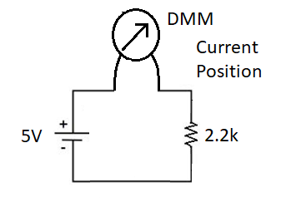
Fig.6. Current Measurement

